**Project Name: Displaying User Feedback**

**Developer Name:** Kapil Davey

**GitHub Link:** [**https://github.com/kapildavey/Phase-3.git**](https://github.com/kapildavey/Phase-3.git)

**OUTPUT:**

**Displaying User Feedback:**

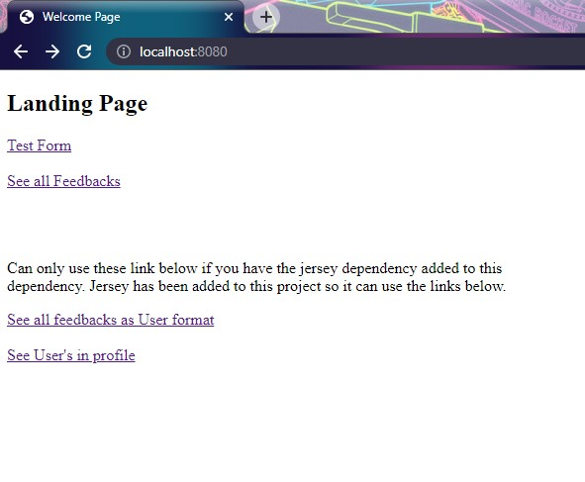

**An entity class Feedback should be made with annotations to link it with the feedback table:**